MACH4METAL

metalworking machinery
Transito 21, 6909 DA Babberich, Netherlands
Tel. + 31 (0)316 – 247123
Fax. + 31 (0)316 - 247956
info@mach4metal.com
www.mach4metal.com
Bank No : 66.52.13.883
IBAN : NL33 INGB 0665 2138 83
BIC : INGBNL2A
VAT : NL 815393635B01

Universal lathe TUJ 560M x 1500

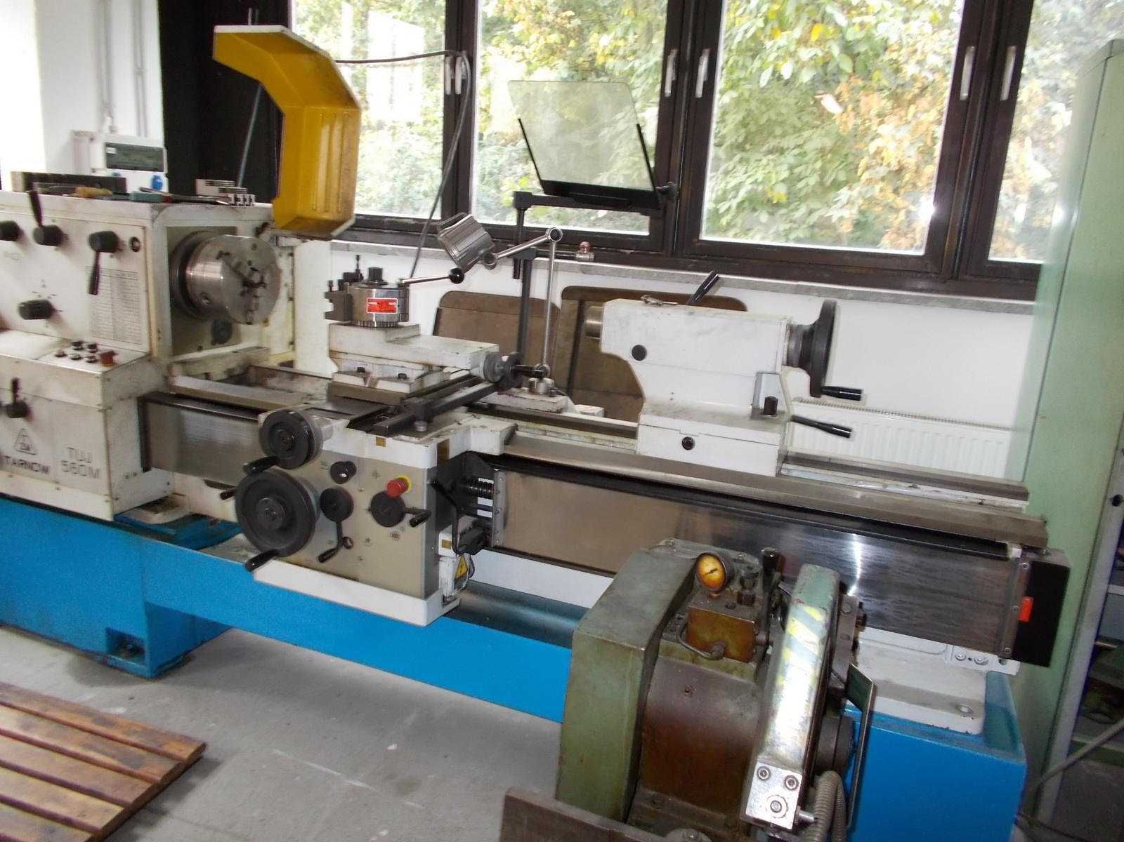
- Make : TARNOW Poland
- Typ : TUJ 560 M
- YOP : 2000
- Mach.No. s/n :

- Swing over bed : 560
- Swing over support : 370
- Swing in the gap : 800

- Gap length : 250
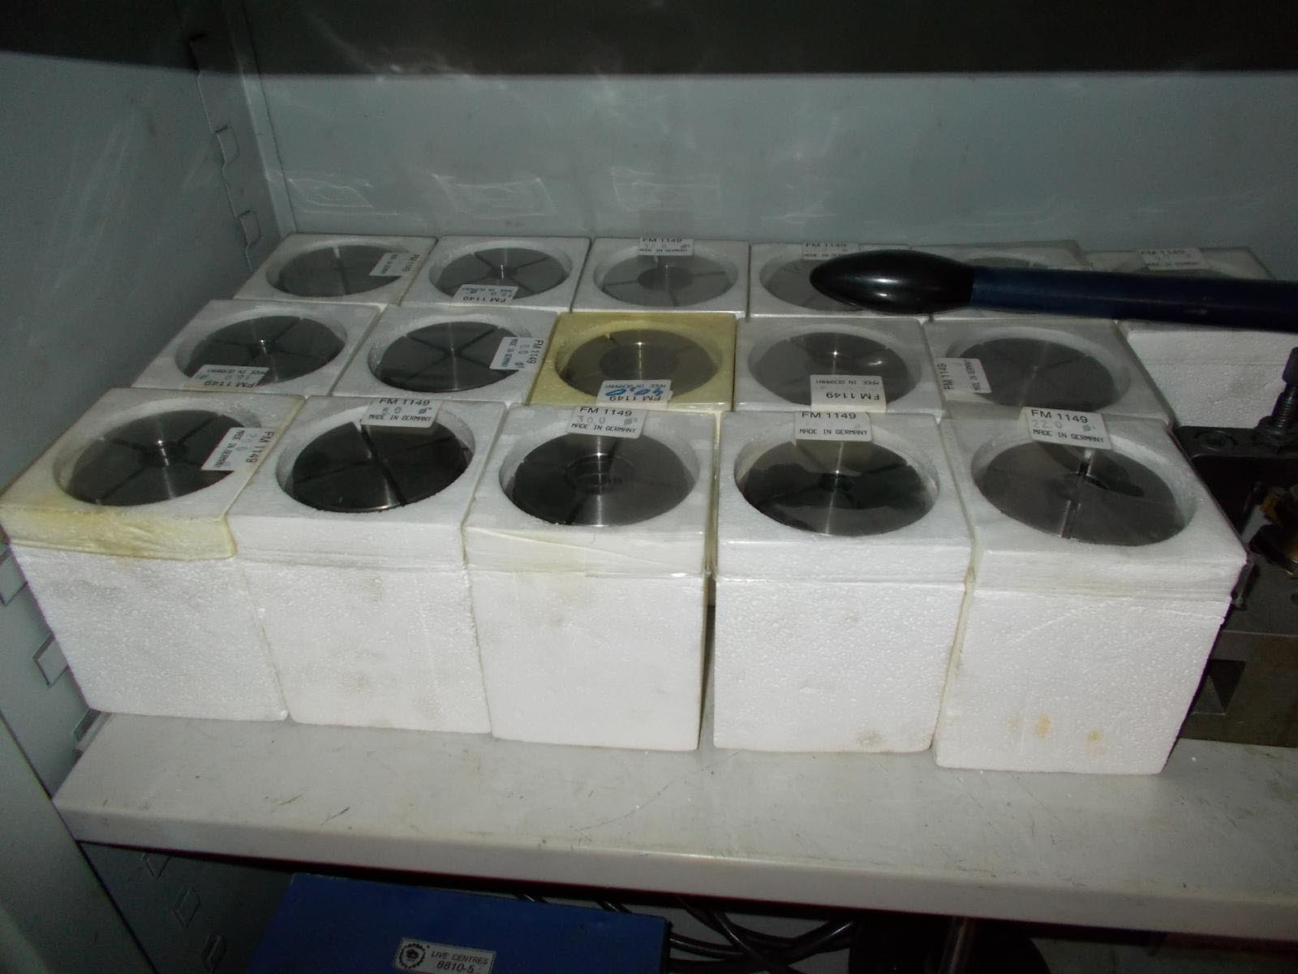
- Spindle hole : 90
- Centre distance : 1.500

- Tailstock pinole : Ø 80
- Pinole stroke : 180
- Pinole Mk : Mk 5
- Speeds 18 x : 1.600 Rpm

- Dimensions
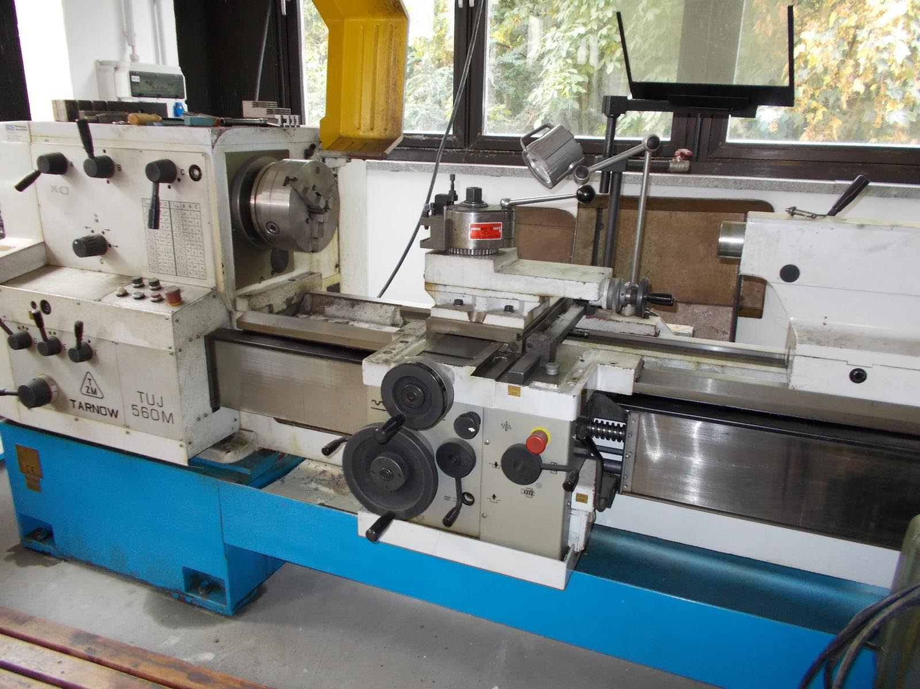
- Length : 3.270
- Width : 1.270
- Height : 1.350
- Weight : 2.790
- Power : 11 kW

- Incl. tool system
- Incl. protection spindle
- Incl. collet device + 16 inserts
- Incl. 4 chuck
- New EUR 40.000

Please Note: The above information has been obtained to the best of our ability and belief from, and from the manufacturers where possible. It is given in good faith, but its accuracy can not be guaranteed. Accordingly, it will not form a representation or constitute contractual terms. We advise you to check any vital details!

